,
STANTON COMMUNITY SCHOOL May 5, 2023

SCHOOL ACTIVITIES
Stanton Music Department
Congratulations to our combined Jr. High/High School Concert Band for receiving a Division II - (Excellent rating at the Annual Richard Simpson Band Festival this past Saturday in Red Oak. The band played Analucia and Arrowhead Overture. The band will now be working on marching band competition music for this next fall.
High School Choir, Boys Choir and Girls Choir will be competing this Friday, May 5th in Winterset, Iowa at the State Large Group Music Contest. We will leave after school on Friday. The Boys Choir will perform "My Heart's in the Highlands" and "I Will Sing Hallelujah" at 6:45pm. The Girls Choir will perform "Sing Alleluiah, Sing." and "Three Spanish Ballades" at 7:30pm. The Combine Choir will perform "Come To Me, O My Love," and "God is Our Refuge" at 8:15pm.
Buy Your Yearbook!
Don't forget to buy your yearbook! As the school year comes to a close, now is the time to preserve those high school memories. Yearbooks are available for purchase on the district web site as well as from any yearbook staff member. Yearbooks start at $65 with personalization available. Anyone interested in purchasing a yearbook should contact Carly Roberts. Carli Smith, Adrian Haynie, Grace Koppa, Jasmine Osher, or Kennedy King for details.
Trash Bag Fundraiser
Stanton Elementary has a large supply of our high-quality trash bags for sale. All three sizes are available! The price for the roll of bags is $12.00. Please contact the elementary office at 829-2171 to purchase bags.
Plant Sale Thank You
Thank you to everyone who supported the PTSO plant sale! We appreciate all our customers.
Athletics
Viqueen Track
The Viqueens competed very well Tuesday night scoring 77 points at the Corner Conference track meet in Griswold. The team collected gold medals in the 4 X 200 relay (Brooklyn Silva, Marleigh Johnson, Addison Olson and Lauren Johnson) and the 4 X 100 relay (Brooklyn Silva, Marleigh Johnson, Hannah Olson, and Lauren Johnson). The Shuttle Hurdle relay team of Addison Olson, Lauren Johnson, Elly McDonald, and Hannah Olson had a 2nd place finish but broke the school record in a time of 1:08.30. Congratulations to the entire team on a great showing at the conference meet.
Junior High Track
The junior high track team continues to work for their success on the oval and their hard work is paying off! Last Thursday, the team competed at the Essex JH Relays. The junior high boys team placed first and the girls team placed second out of the 6 team field. First place finishers for the evening were: Nick Herrick-shot put, Boys Shuttle Hurdle team (N. Herrick, G. Spencer, J. Snow, and C. Dreyer), Distance Medley Team (D. Bruce, G. Kingery, J. Snow, D. McCollum), and Cooper Dreyer in the 100 Hurdles. In the girl’s division, Stanton’s first place entries were: Distance Medley Relay (A. Valdez, J. Castillo, C. Hopf, A. Gettler), Lauren Roberts in the 200 Hurdles, and 4 x 200 *(L. Roberts, V. McFarland, J. Castillo, A. Gettler). Both teams competed and placed very well in all events. On a cold and windy Friday night, the team traveled to F-M and both teams placed fourth overall. Again, there were many personal best and team best results. The team is back on the oval on Friday, May 5th as they travel to

Corning. Next week the team will travel to F-M on Tuesday and will finish up their successful season at Griswold for the Corner Conference JH Meet on Friday, May 12th. So very proud of this very special group!
Clarinda Spring Softball League Updated Schedule
We will make-up the game that got canceled due to weather on 4/16/23. It will now be on 5/07/23.
5/7/23 - North Field 12:40pm/2pm
From the Desk of Our Principal
Thank you to the members of the Junior class, Mrs. Stephens, Ms. Peterson, and our junior and senior parents for helping to plan a successful prom and post prom for our students last Saturday evening.
Senior class parents - please check your email for information regarding end-of-year activities and events for our seniors. If you have any questions please contact Mrs. Elwood.
Teammates Mentoring of Stanton is looking for additional mentors. If you would like to apply to become a mentor, you can find application information at www.teammates.org. If you have any questions regarding mentoring, please contact either Jody Druivenga, Sheila Mainquist, or Katie Elwood at 712-829-2171.
Job Openings:
The district has the following job openings:
- Additional Kindergarten Classroom Teacher
- K-12 Physical Education and Health Teacher
- Food Service Kitchen Assistant
- Food Service Dishwasher
- FB Cheerleading Sponsor
- Temporary Summer Custodial Assistant
Please submit application materials to Katie Elwood, K-12 Principal, at kelwood@stantonschools.com or you may mail application materials to Stanton Community Schools, 605 Elliott Street, Stanton, IA 51573. Information may also be found online at www.teachiowa.gov.
Announcements
YMCA Lifeguard Certification
The Montgomery County YMCA has the following classes coming up to certify lifeguards and recertify:
Certifications:
5/19/23-5/21/23
Recertifications:
4/23/23
5/13/23
Registration information can be found at mcymca.com

COMING EVENTS
Fri., May 5th PTSO Plant Sale in Elem. Concourse
State Large Group Music Festival
Third Grade to Anderson Conservation
4:00 JH Track at Corning
Mon., May 8th 4:30 HS G & B Track at F-M
Tues., May 9th 1:00 Scholarship & Awards Program
4:00 JH Track at Griswold
Wed., May10th 1:05/1:15 Early Dismissal
Boys Sectional Golf
Thurs., May 11th 4:30 B & G Qualifying Track at F-M
Fri., May 12th 4:00 JH Conference Track Meet at F-M
Girls Regional Golf
Sun., May 14th 7:00 Baccalaureate at Mamrelund Church

BREAKFAST MENUS May 8 – May 12th
Monday  Cereal  Muffin/Fruit  Juice/Milk | Tuesday  Waffle  Muffin/Fruit  Juice/Milk | Wednesday  Crescent Roll  Muffin/Fruit  Juice, Milk | Thursday  Pretzel Stick  Muffin/Fruit  Juice/Milk | Friday  Breakfast Pizza  Muffin/Fruit  Juice/Milk
LUNCH MENUS May 8 – May 12th
Monday  Hamburger/Bun  Baked Beans  Tater Twisters,  Peaches, Fruit Medley  Strawberry Cobbler,Milk | Tuesday  Breakfast Pizza  Hashbrown  Juice, Tropical Fruit  Pears  Milk | Wednesday  Stadium Dog  Chili/Cheese  Potato Wedges  Baked Beans, Oranges  Mixed Fruit, Milk | Thursday  Chicken Alfredo  Lettuce  California Vegetables  Pears/Applesauce  Breadstick,Milk | Friday  Walking Taco  Lettuce/Cheese  Corn/Refried Beans  Pineapple  Mandarin Oranges  Goldfish, Milk

ELEMENTARY STUDENT OF THE WEEK MS/JH STUDENT OF THE WEEK

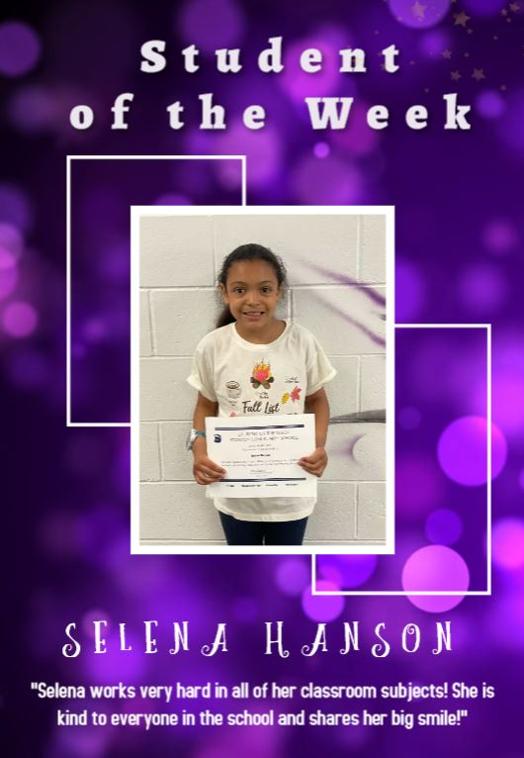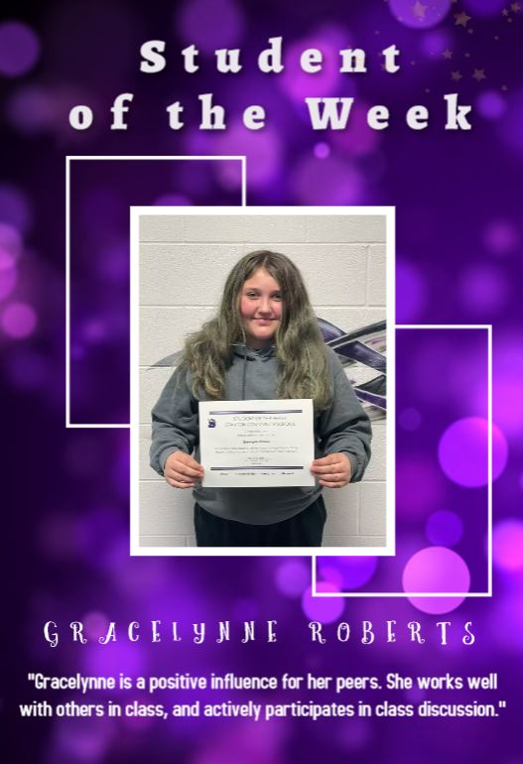

STANTON SCHOOL REGISTRATION
Wednesday, August 9th, 2023

High School Library
8:00 am – 5:00 pm

New Students Entering the District Must Have:
Birth Certificate
Immunization form
Kindergarten Physical (Kindergarten Only)
Parents of New Students:*Please inquire at registration as to if your child needs a dental and or vision form.

You will also:
Apply money towards your child’s lunch/milk/breakfast account
Registration fee: $TBD

*ALL Kindergarten students must have a birth certificate on file before the first day of school in August!! There are no exceptions!

