,
STANTON COMMUNITY SCHOOL May 19, 2023

SCHOOL ACTIVITIES
Buy Your Yearbook!
Don't forget to buy your yearbook! As the school year ends, now is the time to preserve those high school memories. Yearbooks are available for purchase on the district web site as well as from any yearbook staff member. Yearbooks start at $65 with personalization available. Anyone interested in purchasing a yearbook should contact Carly Roberts. Carli Smith, Adrian Haynie, Grace Koppa, Jasmine Osher, or Kennedy King for details.
Thank you Community Helpers!
The First Graders would like to give a big thanks to the following people and businesses for letting the first graders come and visit their place of work and learn about what they do and how they help our community!
*Stanton Fire Station
*Deputy Mitchell, Deputy Askey, and Deputy Kittelson
*FMTC
*John's Heating and A/C Services
*First Interstate Bank
FCCLA Upcoming Blood Drive
The next Red Cross Blood Drive will be on Friday, July 7th at 9:30 -3:30 at the Viking Center. Please go to redcrossblood.org to reserve your appointment.
Trash Bag Fundraiser
Stanton Elementary has a large supply of our high-quality trash bags for sale. All three sizes are available! The price for the roll of bags is $12.00. Please contact the elementary office at 829-2171 to purchase bags.
Athletics
Softball/Baseball Fundraiser
The Stanton High School softball and baseball teams are raising money for the upcoming season. We are needing to raise money for the following items: catcher's mask (softball), game balls (softball), bat (baseball), game balls (baseball), and pitching pocket (baseball).
Please click on the link to purchase Stanton Softball and Baseball Clothing/Gear. The store closes this Sunday night. Thank you for supporting the Stanton students! https://stantonbbsb2023.itemorder.com/shop/home/
Viking Track & Field
Despite the inclement weather, the HS boys' team medaled 14 of their 18 participants at the State Qualifier last week and will be sending their Shuttle Hurdle Relay to the state meet with yet another school record breaking performance. They shaved their previous record time of 1:05.07 down to 1:04.29. The team looks to improve their time yet again at the state meet. Thank you to all who have supported us this season! Go Vikings!
Viqueen Track
The Viqueens finished up the track season with one more excellent effort on a cool, rainy night at their Regional Meet at Corning last Thursday. The girls worked very hard and really improved throughout the season. The Viqueens qualified for three events for the State Track Meet. The shuttle hurdle relay (Addison Olson, Lauren Johnson, Elly McDonald, and Hannah Olson) will run at 9:00 a.m. Thursday morning, Lauren Johnson will long jump at 11:30 Thursday, and the 4 X 100(Brooklyn Silva, Marleigh Johnson, Hannah Olson, and Lauren Johnson) will be on the track Friday at 12:40. Congratulations to the entire track team on a great season! Good Luck to those team members that will be representing Stanton at the state meet.
Mr. Subbert would like to thank Mr. Mainquist and Mr. Grebin for their help and effort throughout the season. Also, thank you to the parents of the girls for all your support. Special thanks to all the team members for all of the hard work you put in to make the season a success.
Junior High Track
The team finished their season at the Corner Conference JH meet on Tuesday nignt at F-M. Once again, we had numerous personal bests and it is so exciting to see the athletes performing their very best at every meet. The team had two first place finishers at the conference meet. Piper French won the girls mile in an outstanding time of 5:55.63

(her best to date!). The girls shuttle hurdle team (Addy Gettler, Piper French, Lilly Ford and Laurent Roberts) won the event with a time of 1:23.02 (their best of the season. Coach Druivenga and Coach Brazeal would like to thank all our parents and supporters who faithfully followed our team to every meet! We are so very very proud of our young tracksters!
From the Desk of Our Principal
Congratulations to our 8th grade students who celebrated their 8th grade graduation on Thursday, May 18th.
Thank you to Stanton Healthy Hometowns for hosting a bike rodeo on Thursday, May 18th for all of our 3rd grade students. We appreciate you sharing information with students about bike safety to prepare for the summer!
Our senior commencement ceremony will be held on Saturday, May 20th at 7 pm in the Stanton School Gymnasium. Congratulations to the graduating class of 2023!
Our last day of school will be Thursday, May 25th. Elementary students will be dismissed at 10:50 am and MS/HS students will be dismissed at 11 am.
Thank you to all of our students, staff, parents, families, and community members for all of your positive support this school year. We want to wish everyone a safe and happy summer break!!
Teammates Mentoring of Stanton is looking for additional mentors. If you would like to apply to become a mentor, you can find application information at www.teammates.org. If you have any questions regarding mentoring, please contact either Jody Druivenga, Sheila Mainquist, or Katie Elwood at 712-829-2171.
Job Openings:
The district has the following job openings:
- Additional Kindergarten Classroom Teacher
- MS/HS Science Teacher
- K-12 Physical Education and Health Teacher
- Head Custodian
- Food Service Kitchen Assistant
- Food Service Dishwasher
- FB Cheerleading Sponsor
- National Honor Society Sponsor
- Marching Band Color Guard Sponsor
- JH Boys Track Coach (2024 season)
- HS Girls Track Coach (2024 season)
Please submit application materials to Katie Elwood, K-12 Principal, at kelwood@stantonschools.com or you may mail application materials to Stanton Community Schools, 605 Elliott Street, Stanton, IA 51573. Information may also be found online at www.teachiowa.gov.
Announcements
2023 Swedish School
Svenska Skolan (Swedish School) is being offered at Stanton’s Swedish Heritage & Cultural Center (SHCC) June 12-16th, Monday through Friday, 9 am to 12 pm (noon). The class is open to children who have completed 1st through 6th grade. There is no cost. To register, please call Yvonne Johnson at 586-4504. Enrollment is limited.
The curriculum will include beginning language, culture, songs, dance, games and crafts. The children will participate in Swedish costume at SHCC’s Midsummar activities on Saturday, June 17th at 5 pm.
New in 2023-the Stanton Summer Market (in place of Farmers Market)!
Check out the Farmers Market vendors, food trucks, entertainment, games, and vendors of all kinds. The Stanton Summer Market is the first Saturday of the month (June 3rd, July 1st, August 5th, and September 2nd) from 8:30am-11:00am in Downtown Stanton. Vendors wanted and cost is $25 for 4 events. A special thanks to FMTC, First Interstate Bank, Red Oak Chrysler, Bank Iowa, Stanton Chamber of Commerce and Rex’s Plumbing and Heating! For more information, contact Jenna Ramsey at 712-829-7340 or jramsey@fmtcnet.com or Justin Miller at 712-829-2900 or vikingcenter@myfmtc.com.
Taco Ride Mexican Nights
Ride your bike of any kind (or just come and join the fun) to Stanton for Taco Ride Mexican Nights! These summer nights will be on Thursdays (May 25th, June 29th, July 27th and August 31st) from 5pm-9pm in Downtown Stanton at Gibbs Chophouse and more TBD. A special thanks to FMTC, First Interstate Bank, Red Oak Chrysler, Bank Iowa, Rex’s Plumbing & Heating, and Stanton Chamber of Commerce!
Summer Movie Nights-FREE!
New in 2023-Outdoor Movies! Join us behind the old gas station on Main Street for movies starting at 9pm. The first two dates are Friday, June 16th and Friday, July 21st with more pop up nights to come! A special thanks to FMTC, First Interstate Bank, Red Oak Chrysler, Bank Iowa, Rex’s Plumbing & Heating, and Stanton Chamber of Commerce!
Stanton Summer Concert Live Music Series-FREE!
Night #1-Water Trail Night on June 7th at 7pm, Owen Justice at Danny Anderson Field
Night #2-After Midsommar on June 17th, Eric Nelson at Swedish Heritage & Cultural Center
Night #3-July 14th at 7pm, Tyler Folkerts in Downtown Stanton
Night #4-August 3rd at 7pm, Jim Nelson in Downtown Stanton
Night #5-August 19th at 7pm, Holiday Drive-Mikey Dean “OLY 5 Year Celebration” at Stanton Old Lumber Yard Event Center
Special thanks to Hilltop Auto Body, John’s Heating & Air, Dental Care PC, Orme Outdoor, Rex’s Plumbing & Heating, Bank Iowa, Red Oak Chrysler, First Interstate Bank, FMTC, and Stanton Chamber of Commerce
Baby Sitting Basics Course Offered by Ext. Office
The Montgomery County Extension Office is hosting a Babysitting Basics Course for students in grades 5-9 on May 31st from 9:00 AM- 3:00 PM at the Montgomery County Extension Office. Participants will learn the basics of taking care of children of all ages and stages. There is a registration fee of $20 and lunch is provided. To register, please call the Montgomery County Extension Office at 712-623-2592 or email Sadie Graham at sagraham@iastate.edu.
COMING EVENTS
Sat., May 20th 7:00 Senior Graduation
State Track
Mon., May 22nd 5:30 SB/BB w SWV
Tues., May 23rd 5:30 SB/BB w Essex
Wed., May 24th 1:05/1:15 Early Dismissal
Thurs., May 25th 10:50/11:00 Early Dismissal
End of Fourth Quarter
Last Day of School!
Fri., May 26th 5:30 SB/BB at Griswold
Sat., May 27th 9:00 Red Oak SB Tournament

BREAKFAST MENUS May 22 – May 25th
Monday  COOK’S CHOICE | Tuesday  COOK’S CHOICE | Wednesday  COOK’S CHOICE | Thursday  COOK’S CHOICE | Friday  SUMMER!!
LUNCH MENUS May 22 – May 25th
Monday  COOK’S CHOICE | Tuesday  COOK’S CHOICE | Wednesday  COOK’S CHOICE | Thursday  SUMMER! | Friday  SUMMER!

ELEMENTARY STUDENT OF THE WEEK MS/JH STUDENT OF THE WEEK

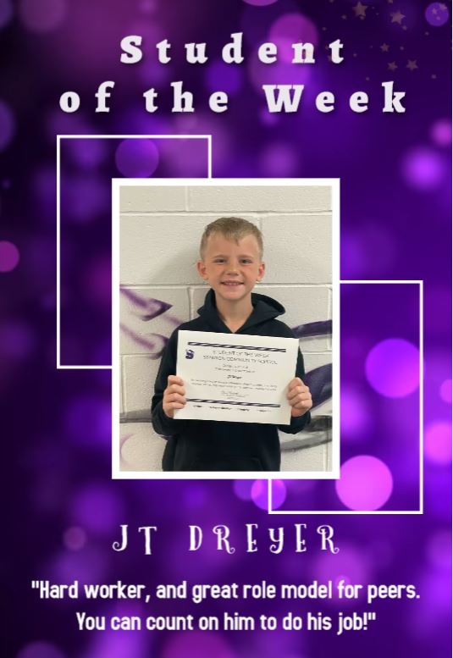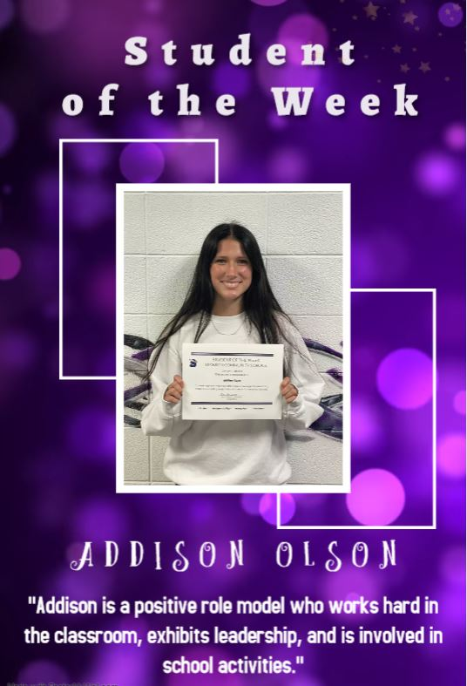
STANTON SCHOOL REGISTRATION
Wednesday, August 9th, 2023

High School Library
8:00 am – 5:00 pm

New Students Entering the District Must Have:
Birth Certificate
Immunization form
Kindergarten Physical (Kindergarten Only)
Parents of New Students:*Please inquire at registration as to if your child needs a dental and or vision form.

You will also:
Apply money towards your child’s lunch/milk/breakfast account
Text Book fee: $90 ($270 cap)

