,
STANTON COMMUNITY SCHOOL May 12, 2023

SCHOOL ACTIVITIES
Buy Your Yearbook!
Don't forget to buy your yearbook! As the school year ends, now is the time to preserve those high school memories. Yearbooks are available for purchase on the district web site as well as from any yearbook staff member. Yearbooks start at $65 with personalization available. Anyone interested in purchasing a yearbook should contact Carly Roberts. Carli Smith, Adrian Haynie, Grace Koppa, Jasmine Osher, or Kennedy King for details.
Third Grade Bike Rodeo
Stanton Healthy Hometowns is planning to host a bike rodeo on Thursday, May 18th for all of our 3rd grade students. We are asking 3rd graders to please bring their bicycle helmets from home to be fitted. We will have helmets available that day for anyone who does not have a helmet. The kids are also encouraged to bring their bikes or scooters on May 18th. Please feel free to drop the bicycles or scooters off at school in the morning. Thank you to Stanton Healthy Hometowns for helping plan and support this activity for our students. We look forward to teaching students about bike safety as we prepare for the summer! If you have any questions, please contact Mrs. Elwood at 712-829-2162.
Stanton Music Department
Congratulations to our HS Vocal Music students who participated in the State Large Group Contest this past Friday in Winterset. The Girls’ Choir and Boys Choir each received a III (Good Rating) and the Combined Mixed Chorus received a II (Excellent Rating)! The choir will be performing at the upcoming Senior Commencement on Saturday, May 20th at 7pm.
FCCLA Upcoming Blood Drive
There will be a Red Cross Blood drive this summer sponsored by FCCLA. Be looking for the date and times.
Trash Bag Fundraiser
Stanton Elementary has a large supply of our high-quality trash bags for sale. All three sizes are available! The price for the roll of bags is $12.00. Please contact the elementary office at 829-2171 to purchase bags.
Athletics
Softball/Baseball Fundraiser
The Stanton High School softball and baseball teams are raising money for the upcoming season. We are needing to raise money for the following items: catcher's mask (softball), game balls (softball), bat (baseball), game balls (baseball), and pitching pocket (baseball).
Please click on the link to purchase Stanton Softball and Baseball Clothing/Gear. The store closes this Sunday night. Thank you for supporting the Stanton students! https://stantonbbsb2023.itemorder.com/shop/home/
Viking Track & Field
The team has been showing improved times and distances. The shuttle hurdle team broke their own record again, this time putting them in the top 15 in Class 1A. The team of Joshua Martin, Nolan Grebin, Gavin Ford, and Jacob Martin looks to compete well at the state qualifying meet to perform at Drake Stadium next Thursday along with the Stanton girls shuttle team. Other events are shaping up to be top performances, but we'll have to wait until results are available to see if any of them will also qualify. Go Vikings!
Viqueen Track
The track season is quickly coming to an end. The Viqueens have competed in meets at Southwest Valley and Fremont Mills in the last week. The girls continue to perform at a high level and are preparing for the Regional Meet. The shuttle hurdle relay team (Addison
Olson, Lauren Johnson, Elly McDonald, and Hannah Olson) broke their own school record running a time of 1:06.96 at the Southwest Valley meet. Great job girls!

Junior High Track
The team traveled to Corning on Friday night and had some outstanding results. On Tuesday night, the team was in Griswold and again had some stellar results. In fact, 5 girls relays and 5 boys relays set personal best times for the season at Griswold! The team will finish their season at the Corner Conference JH meet this Friday night at F-M. What a season of growth it has been for this squad! We would like to thank all our supporters from the stands, the parents that continue to keep us nourished (and spoiled) at track meets and our bus driver, Mr. Boyer for getting us to and from our meets safely. We are so very proud to represent our school and our community!
From the Desk of Our Principal
Tuesday, May 9th was our Scholarship and Awards Day for our Middle School and High School students. Thank you to everyone who helped present these awards. We appreciate everyone taking time out of their day to recognize the accomplishments of our students. Congratulations to all our scholarship and award recipients!!
Teammates Mentoring of Stanton is looking for additional mentors. If you would like to apply to become a mentor, you can find application information at www.teammates.org. If you have any questions regarding mentoring, please contact either Jody Druivenga, Sheila Mainquist, or Katie Elwood at 712-829-2171.
Job Openings:
The district has the following job openings:
- Additional Kindergarten Classroom Teacher
- MS/HS Science Teacher
- K-12 Physical Education and Health Teacher
- Head Custodian
- Food Service Kitchen Assistant
- Food Service Dishwasher
- FB Cheerleading Sponsor
- National Honor Society Sponsor
- HS Girls Track (2023-24)
- JH Boys Track (2023-24)
- Marching Band Color Guard Sponsor (2023-24)
Please submit application materials to Katie Elwood, K-12 Principal, at kelwood@stantonschools.com or you may mail application materials to Stanton Community Schools, 605 Elliott Street, Stanton, IA 51573. Information may also be found online at www.teachiowa.gov.
Announcements
2023 Swedish School
Svenska Skolan (Swedish School) is being offered at Stanton’s Swedish Heritage & Cultural Center (SHCC) June 12-16th, Monday through Friday, 9 am to 12 pm (noon). The class is open to children who have completed 1st through 6th grade. There is no cost. To register, please call Yvonne Johnson at 586-4504. Enrollment is limited.
The curriculum will include beginning language, culture, songs, dance, games and crafts. The children will participate in Swedish costume at SHCC’s Midsummar activities on Saturday, June 17th at 5 pm.

New in 2023-the Stanton Summer Market (in place of Farmers Market)!
Check out the Farmers Market vendors, food trucks, entertainment, games, and vendors of all kinds. The Stanton Summer Market is the first Saturday of the month (June 3rd, July 1st, August 5th, and September 2nd) from 8:30am-11:00am in Downtown Stanton. Vendors wanted and cost is $25 for 4 events. A special thanks to FMTC, First Interstate Bank, Red Oak Chrysler, Bank Iowa, Stanton Chamber of Commerce and Rex’s Plumbing and Heating! For more information, contact Jenna Ramsey at 712-829-7340 or jramsey@fmtcnet.com or Justin Miller at 712-829-2900 or vikingcenter@myfmtc.com.

Taco Ride Mexican Nights
Ride your bike of any kind (or just come and join the fun) to Stanton for Taco Ride Mexican Nights! These summer nights will be on Thursdays (May 25th, June 29th, July 27th and August 31st) from 5pm-9pm in Downtown Stanton at Gibbs Chophouse and more TBD. A special thanks to FMTC, First Interstate Bank, Red Oak Chrysler, Bank Iowa, Rex’s Plumbing & Heating, and Stanton Chamber of Commerce!
Summer Movie Nights-FREE!
New in 2023-Outdoor Movies! Join us behind the old gas station on Main Street for movies starting at 9pm. The first two dates are Friday, June 16th and Friday, July 21st with more pop up nights to come! A special thanks to FMTC, First Interstate Bank, Red Oak Chrysler, Bank Iowa, Rex’s Plumbing & Heating, and Stanton Chamber of Commerce!
Stanton Summer Concert Live Music Series-FREE!
Night #1-Water Trail Night on June 7th at 7pm, Owen Justice at Danny Anderson Field
Night #2-After Midsommar on June 17th, Eric Nelson at Swedish Heritage & Cultural Center
Night #3-July 14th at 7pm, Tyler Folkerts in Downtown Stanton
Night #4-August 3rd at 7pm, Jim Nelson in Downtown Stanton
Night #5-August 19th at 7pm, Holiday Drive-Mikey Dean “OLY 5 Year Celebration” at Stanton Old Lumber Yard Event Center
Special thanks to Hilltop Auto Body, John’s Heating & Air, Dental Care PC, Orme Outdoor, Rex’s Plumbing & Heating, Bank Iowa, Red Oak Chrysler, First Interstate Bank, FMTC, and Stanton Chamber of Commerce
Baby Sitting Basics Course Offered by Ext. Office
The Montgomery County Extension Office is hosting a Babysitting Basics Course for students in grades 5-9 on May 31st from 9:00 AM- 3:00 PM at the Montgomery County Extension Office. Participants will learn the basics of taking care of children of all ages and stages. There is a registration fee of $20 and lunch is provided. To register, please call the Montgomery County Extension Office at 712-623-2592 or email Sadie Graham at sagraham@iastate.edu.
YMCA Lifeguard Certification
The Montgomery County YMCA has the following classes coming up to certify lifeguards and recertify:
Certifications:
5/19/23-5/21/23
Recertifications:
5/13/23
Registration information can be found at mcymca.com

COMING EVENTS
Fri., May 12th 4:00 JH Conference Track Meet at F-M
Girls Regional Golf
Sun., May 14th 7:00 Baccalaureate at Mamrelund Church
Mon., May 15th Senior Trip
Tues., May 16th Senior Trip
Wed., May 17th 1:05/1:15 Early Dismissal
Senior Trip
Thurs., May 18th Seniors Last Day
State Track
Fri., May 19th State Track
5:30 JV/V BB w AHSTW
Sat., May 20th 7:00 Senior Graduation
State Track

BREAKFAST MENUS May 15 – May 19th
Monday  Dutch Waffle  Muffin/Fruit  Juice/Milk | Tuesday  Donut  Muffin/Fruit  Juice/Milk | Wednesday  Breakfast Bar  Muffin/Fruit  Juice, Milk | Thursday  Soft Cereal Bar  Muffin/Fruit  Juice/Milk | Friday  Pancake/Sausage on a Stick  Muffin/Fruit  Juice/Milk
LUNCH MENUS May 15 – May 19th
Monday  Crispito/Hot Dog  Corn  Potato Salad  Raisins, Strawberries  Milk | Tuesday  Cheesy Pull-A-Parts  Lettuce  Carrots, Pears  Applesauce  Milk | Wednesday  Grilled Chicken/Bun  Mixed Veggies  Cheesy Broccoli  Oranges, Ice Cream Milk | Thursday  Beef Sticks  Mashed Potatoes/Gravy  Cooked Carrots  Peaches/Mixed Fruit  Roll, Milk | Friday  Deep Dish Pizza  French Fries  Celery  Cantaloupe  Applesauce  Milk

ELEMENTARY STUDENT OF THE WEEK MS/JH STUDENT OF THE WEEK

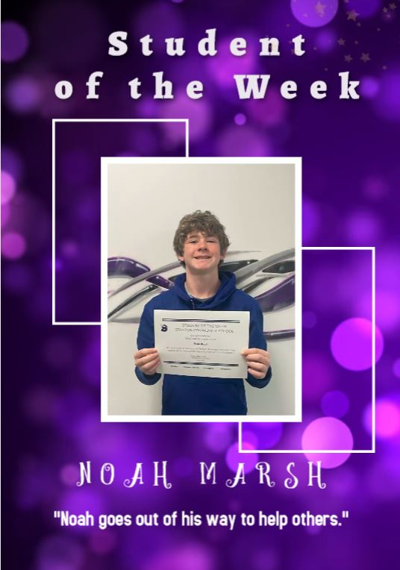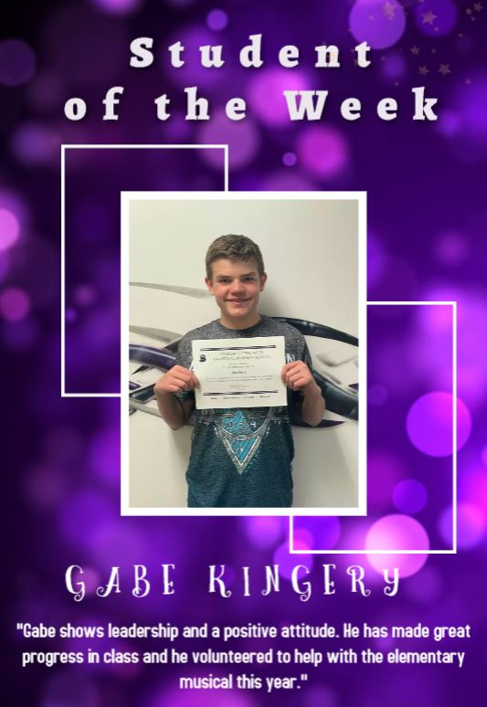

STANTON SCHOOL REGISTRATION
Wednesday, August 9th, 2023

High School Library
8:00 am – 5:00 pm

New Students Entering the District Must Have:
Birth Certificate
Immunization form
Kindergarten Physical (Kindergarten Only)
Parents of New Students:*Please inquire at registration as to if your child needs a dental and or vision form.

You will also:
Apply money towards your child’s lunch/milk/breakfast account
Registration fee: $TBD

