,
STANTON COMMUNITY SCHOOL December 2nd, 2022

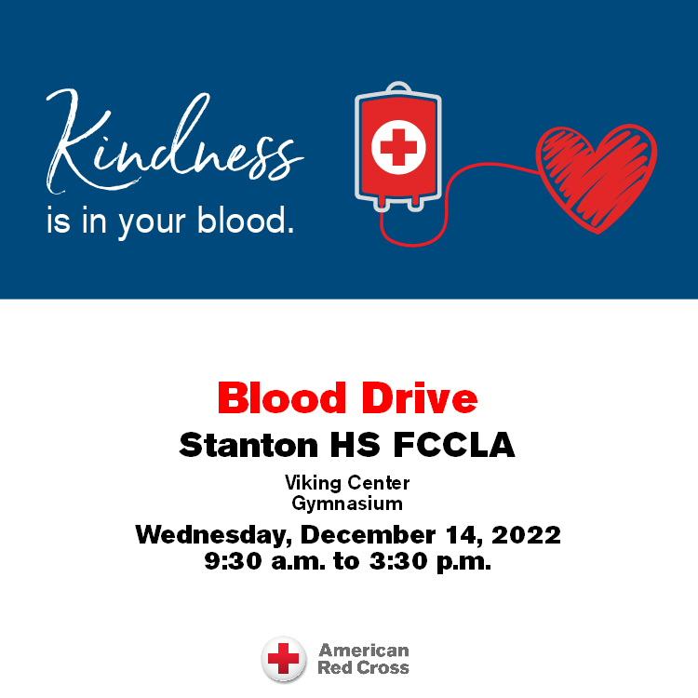

Please join us for a blood drive at Stanton HS FCCLA on Wednesday, December 14, 2022 from 9:30 a.m. to 3:30 p.m. Visit RedCrossBlood.org to schedule an appointment.

SCHOOL ACTIVITIES
Santa Lucia
We are busy getting prepared for our annual Santa Lucia Festival of Lights which will be held next Saturday, December 10th, 7 p.m. at the Stanton High School Gym. Grades K-6 will take part in this nostalgic Festival. Mr. Lantz would like for the children to be at the gym between 6:45 – 6:50 p.m., SEATED QUIETLY, on the stage bleachers on the north end of the stage. The Fourth, Fifth and Sixth grade students should go to the weight room no later than 6:50 p.m. It is very important for every student to participate as it is part of the music curriculum and their music grade. The students should wear the following:
Boys: White shirts, dark pants, red vest or bow/ribbon tie (if you have one) or red suspenders.
Girls: White blouse, red, blue or yellow skirt, striped apron (if you have one), red tights or knee socks and floral rings for your hair (if you have one)
Get Your Yearbook!
Yearbooks are on sale! Yearbooks can be ordered online by clicking the Jostens banner on the school website. You may also contact a yearbook staff member to order a yearbook. Yearbooks start at $50 and can be personalized for additional cost. After December 23, prices increase to $65 so order your yearbook early to save money! Contact Carli Smith, Carly Roberts, Adrian Haynie, Jasmine Osher, Grace Koppa, Kennedy King, or April Vanderholm to order a yearbook today!
FFA Fruit Sales
FFA Fruit Sales items will be here on Monday, December 5th. Expect FFA members to begin delivering orders Monday after school. All deliveries should be completed by Wednesday, December 7th. Thank you to all who ordered and supported the Stanton FFA Chapter this year!
Community Pep Band Rehearsals
All who play musical instruments wanted! Come join us on Tuesday evenings at 7pm in the High School Music Room.
We are working on Christmas music to play at the OLY for the Legion Santa on Saturday, December 17th. We will also play at some of the upcoming basketball games. All are welcome! It's a blast!!
Become a Teammates Mentor!
Are you ready to be a champion in the life of a Stanton student? We want you on our TEAM! The Stanton TeamMates Mentoring Program is looking for caring adults in the community to serve as mentors for our students! Call 712-829-2162 to learn more!
Become a Mentor today. Please go to teammates.org for more information.

COMING EVENTS
Tuesday, Dec. 6th 4:00 JH BB w Griswold
Girls-T, Boys-H
6:00 HS BB at Griswold
Wednesday, Dec 7th Early Dismissal 1:05/1:15 pm
Friday, Dec. 9th 4:00 JH BB w East Mills
Girls at VC, Boys-T
6:00 HS BB at East Mills
Saturday, Dec 10th 7:00 Santa Lucia in the gym

ANNOUNCEMENTS
Turkey Trot “Thank You”
Abby and Jenna would like to thank everyone who donated, walked, trot, ran, or waddled in the Turkey Trot fundraiser. We had a great turnout and the money raised will go toward purchasing a memorial for “The Courts” in honor of Kevin Blunt.
First Interstate Bank Coat Drive
All branches of the First Interstate Bank are sponsoring a coat drive. Gently used coats and other winter gear can be brought to the collection box in the bank lobby or our local branch in Stanton through December 3rd. All items collected will be taken to West Central Development for distribution to those in need.
Christmas at the OLY
The Stanton Old Lumber Yard Event Center is excited to announce dates for the Christmas Drive-Thrus where you can experience over 40 Christmas trees, lights and more! Dates include Saturday, December 10th after Santa Lucia; Sunday, December 11th from 6pm-8pm, Saturday, December 17th from 5pm-7pm (Legion Santa); Sunday, December 18th from 6pm-8pm and Thursday, December 22nd from 6pm-8pm. Donations to the local food pantry are requested but not required to drive through.
Stanton’s Legion Santa Claus
Stanton children up to and including second grades are invited to walk through and see Santa Claus at the Stanton Old Lumber Yard Event Center on Saturday, December 17th from 5pm-7pm. Anyone is welcome to walk through and see Santa, but only those who call Santa’s helpers will receive gifts. The high school choir will provide music. Hot chocolate and apple cider will be served. Santa’s helpers will be waiting to talk on the phone (712)829-2687 to the children on Wednesday, December 14th and Thursday, December 15th from 5:30pm-7:30pm. Be sure to tell Santa each child’s name. Give this information clearly in order that Santa will not forget anyone!

BREAKFAST MENUS DECEMBER 5th- DECEMBER 9th
Monday  Cereal Bar  Muffin/Fruit  Juice/Milk | Tuesday  French Toast  Muffin/Fruit  Juice, Milk | Wednesday  Crescent Roll  Muffin/Fruit  Juice/Milk | Thursday  Breakfast Pizza  Muffin/Fruit  Juice/Milk | Friday  Omelet/Toast  Muffin/Fruit  Juice/Milk

LUNCH MENUS DECEMBER 5th- DECEMBER 9th
Monday  Fiestada  Lettuce  Corn  Pears  Applesauce  Milk | Tuesday  Ham & Potato Casserole  Peas  Green Beans  Mixed Fruit  Mandarin Oranges, Roll  Milk | Wednesday  Stadium Dog  Chili/Cheese  Potato Wedges  Baked Beans  Strawberries, Pears  Milk | Thursday  Siracha Chicken  Fried Rice  Cooked Carrots  Egg Roll  Peaches, Applesauce  Milk | Friday  Walking Taco  Lettuce/Cheese  Refried Beans  Corn  Pineapple, Fruit Medley  Goldfish, Milk

ELEMENTARY MS/HS

