,
STANTON COMMUNITY SCHOOL November 18, 2022

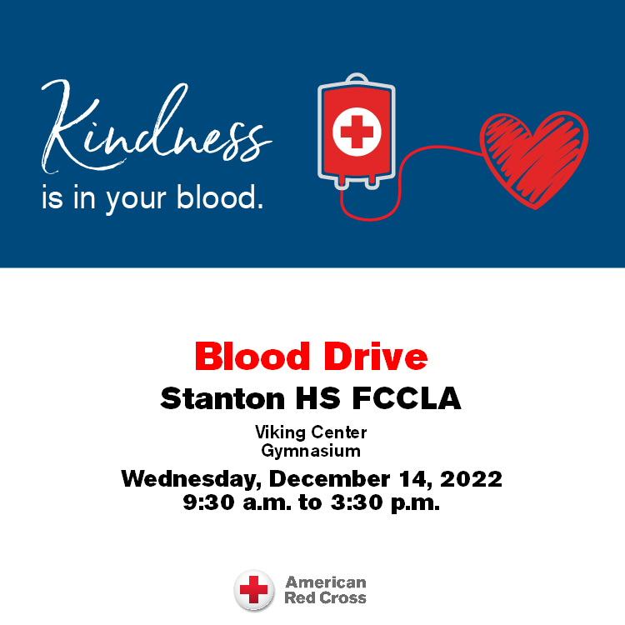

Please join us for a blood drive at Stanton HS FCCLA on Wednesday, December 14, 2022 from 9:30 a.m. to 3:30 p.m. Visit RedCrossBlood.org to schedule an appointment.

SCHOOL ACTIVITIES
CORNER CONFERENCE SCIENCE FAIR
The Conference Science Fair will be on November 22 in Hamburg. A few students will be chosen to attend the Conference Science Fair and compete for a medal. Also, each school must provide judges. If you are interested and willing to be a judge, please contact Mrs. Embray at aembray@stantonschools.com. It is always interesting to see and hear about what students are doing in science! Come and be a part of this fun tradition!
Santa Lucia
We are busy getting prepared for our annual Santa Lucia Festival of Lights which will be held Saturday, December 10th, 7 p.m. at the Stanton High School Gym. Grades K-6 will take part in this nostalgic Festival. Mr. Lantz would like for the children to be at the gym between 6:45 – 6:50 p.m., SEATED QUIETLY, on the stage bleachers on the north end of the stage. The Fourth, Fifth and Sixth grade students should go to the weight room no later than 6:50 p.m. It is very important for every student to participate as it is part of the music curriculum and their music grade. The students should wear the following:
Boys: White shirts, dark pants, red vest or bow/ribbon tie (if you have one) or red suspenders.
Girls: White blouse, red, blue or yellow skirt, striped apron (if you have one), red tights or knee socks and floral rings for your hair (if you have one)
Stanton FFA
On Tuesday, November 15th, the Stanton FFA Chapter held their Jacket Unboxing and Degree Raising Ceremonies. Congratulations to the seven members receiving their Greenhand Degree and to the thirteen members receiving their Chapter Degree.
Students work diligently to achieve the requirements needed for their respective degree. Seven students received their Greenhand Degree; Clayton Culver, Cale Haley, Adrian Haynie, Ethyn Jordan, Eric Kutzli, Brianna Mitchell and Wyatt Roberts Thirteen students received their Chapter Degree these members were Zooey Allen, Stephanie Bair, Hunter Bishop, Alice Duckett, Andrew Johnson, Jameson McDonald, Logan McQueen, Kyle

Pastore, Ella Peterson, Caden Sallach, Jayden Schwery, Clark Spencer, and Marissa Strough. Two students participated in the Jacket Unboxing Ceremony: Clayton Culver and Ethyn Jordan.
Greenhand Degree recipients have planned their Supervised Agricultural Experience (work- based experience); learned and explained the FFA Creed, motto, and mission statement; described and explained the meaning of the FFA emblem and colors; demonstrated knowledge of the FFA Code of Ethics and the proper use of the FFA jacket; and demonstrated a knowledge of the history of the organization, the chapter constitution and bylaws and the Chapter Program of Activities.
Chapter Degree recipients have earned their Greenhand FFA Degree, developed plans for continued growth and improvement in their Supervised Agricultural Experience, have effectively led a group discussion for 15 minutes, have demonstrated five procedures of parliamentary law, shown progress toward individual achievement in the FFA award programs, have a satisfactory scholastic record, and have participated in at least 10 hours of community service activities.
Community Pep Band Rehearsals
If you have played an instrument in the past, come and join us on Tuesday evenings at 7pm. We are working on Christmas songs to play at the Legion Santa at the OLY on Saturday, December 17th. Any questions contact Mr. Lantz at llantz@stantonschools.com
Become a Teammates Mentor!
Are you ready to be a champion in the life of a Stanton student? We want you on our TEAM! The Stanton TeamMates Mentoring Program is looking for caring adults in the community to serve as mentors for our students! Call 712-829-2162 to learn more!
Become a Mentor today. Please go to teammates.org for more information.
Kindness Quilt
Stanton Elementary students will be participating in The Kindness Quilt Project. Each November we typically think of all the things we are thankful for. This November let’s give others a reason to be thankful for us.
Please complete random acts of kindness throughout the month of November. Report back to school with a note or email to your child’s teacher. Your child will then write down each act of kindness her or she completes on a quilt square provided.
We’ll see just how big our kindness can be by how big our quilt gets. The goal would be for your child to complete one act of kindness towards others each week in the month of November.
ATHLETICS
More Post-Season Volleyball Honors
Congratulations to Marleigh Johnson, Jenna Stephens and Lauren Johnson who were named to the IGCA 1A All-District (Southwest) team! This is an impressive honor as only 20 athletes were named from the 22 schools included in the Southwest District. So very proud of our Viqueens!
COMING EVENTS
Monday Nov. 21st 4:00 JH Boys BB w E. Mills
Tuesday, Nov. 22nd JH Conf. Science Fair @ Hamburg
Wednesday, Nov. 23rd NO SCHOOL
Thursday, Nov. 24th NO SCHOOL
Happy Thanksgiving to all!
Friday, Nov. 25th NO SCHOOL
Monday, Nov. 28th 4:00 JH BB w Lenox
Tuesday, Nov. 29th 3:45 JV BB @ Coon Rapids
6:00 HS BB @ Coon Rapids
Wednesday, Nov. 30th 1:05/1:15 Early Dimissal
Thursday, Dec. 1st 7:30 AM FFA Metting
Friday, Dec. 2nd 4:00 JH BB w Sidney
6:00 HS BB w Sidney

ANNOUNCMENTS
First Interstate Bank Coat Drive
All branches of the First Interstate Bank are sponsoring a coat drive. Gently used coats and other winter gear can be brought to the collection box in the bank lobby or our local branch in Stanton through December 3rd. All items collected will be taken to West Central Development for distribution to those in need.
“The Courts” Turkey Trot
On Saturday, November 19th, there will be a “Turkey Trot” run on the Stanton Trail with all proceeds going to purchase a sign or bench for “The Court” – The Kevin Blunt Memorial Basketball Court. All participants should meet at the Stanton Viking Center and the run will begin at 8 am. Registration is a free will offering with Venmo and checks accepted. To register and for any information, please contact Lacey Stephens at 402-650-7173.
Marketplace Off Main Craft and Vendor Show
Join us for the Annual Marketplace Off Main Craft and Vendor Show on Sunday, November 20th. Check out a variety of craft and vendors at the Stanton Old Lumber Yard Event Center from 1pm-4pm. Limited vendor space is available. Contact Jenna Ramsey at 712-829-7340 for space. We hope to see you there!
Christmas Tree Decorating Opportunity
The Stanton Old Lumber Yard Event Center is getting ready for another year of holiday cheer. This year, over 40 trees will be set up at the OLY and decorators are needed! We invite families and community organizations to bring decorations to decorate a tree for Santa’s sleigh area. Trees can be decorated any time between November 22nd-26th. If you are interested, contact the Old Lumber Yard Event Center at (712)829-7350.
Christmas at the OLY
The Stanton Old Lumber Yard Event Center is excited to announce dates for the Christmas Drive-Thrus where you can experience over 40 Christmas trees, lights and more! Dates include Saturday, December 10th after Santa Lucia; Sunday, December 11th from 6pm-8pm, Saturday, December 17th from 5pm-7pm (Legion Santa); Sunday, December 18th from 6pm-8pm and Thursday, December 22nd from 6pm-8pm. Donations to the local food pantry are requested but not required to drive through.
Stanton’s Legion Santa Claus
Stanton children up to and including second grades are invited to walk through and see Santa Claus at the Stanton Old Lumber Yard Event Center on Saturday, December 17th from 5pm-7pm. Anyone is welcome to walk through and see Santa, but only those who call Santa’s helpers will receive gifts. The high school choir will provide music. Hot chocolate and apple cider will be served. Santa’s helpers will be waiting to talk on the phone (712)829-2687 to the children on Wednesday, December 14th and Thursday, December 15th from 5:30pm-7:30pm. Be sure to tell Santa each child’s name. Give this information clearly in order that Santa will not forget anyone!

BREAKFAST MENUS NOVEMBER 21- NOVEMBER 25th
Monday  Cereal  Muffin/Fruit  Juice/Milk | Tuesday  Bagel Bites  Muffin/Fruit  Juice, Milk | Wednesday  NO SCHOOL | Thursday  NO SCHOOL | Friday  NO SCHOOL

BREAKFAST MENUS NOVEMBER 28- DECEMBER 2nd
Monday  Pop Tart  Muffin/Fruit  Juice/Milk | Tuesday  Breakfast Sandwich  Muffin/Fruit  Juice, Milk | Wednesday  Oatmeal Bar  Muffin/Fruit  Juice, Milk | Thursday  Bacon & Egg Pizza  Muffin/Fruit  Juice/Milk | Friday  Pancakes  Muffin/Fruit  Juice/Milk

LUNCH MENUS NOVEMBER 21- NOVEMBER 25th
Monday  Stuffed Crust Pizza  Lettuce  Broccoli  Applesauce  Pears  Milk | Tuesday  Creamed Turkey  Mashed Potatoes  Green Beans  Sweet Potatoes, Dressing  Peaches, Mixed Fruit  Pumpkin Dessert, Milk | Wednesday  NO SCHOOL | Thursday  NO SCHOOL | Friday  NO SCHOOL

LUNCH MENUS NOVEMBER 28- DECEMBER 2nd
Monday  Rib/Hot Dog  Baked Beans  Cheesy Potato Bites  Mandarin Oranges  Pineapple, Milk | Tuesday  Chicken Pattie/Bun  Mixed Veggies  Tomato Juice  Applesauce  Ice Cream, Milk | Wednesday  Sloppy Joe  Cheesy Broccoli  Potato Spudsters  Mixed Fruit  Apricots, Milk | Thursday  Pork Pattie  Mashed Potatoes/Gravy  Cooked Carrots  Peaches  Pineapple, Roll, Milk | Friday  Biscuits & Gravy  Hashbrown  Juice  Tropical Fruit/Pears  Animal Crackers, Milk

ELEMENTARY MS/HS
