,
STANTON COMMUNITY SCHOOL November 11, 2022

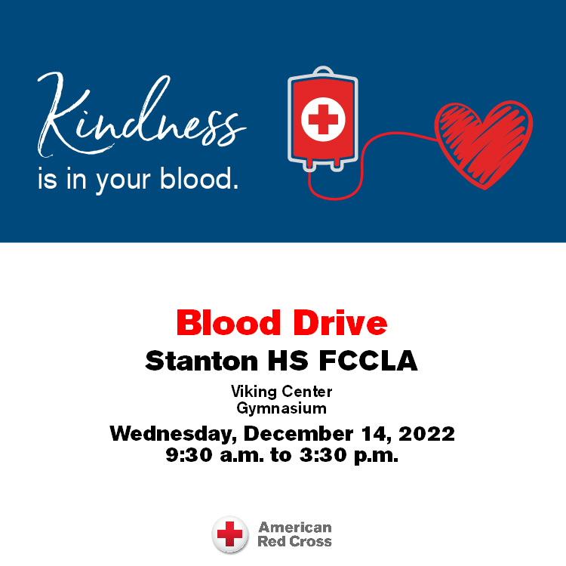

Please join us for a blood drive at Stanton HS FCCLA on Wednesday, December 14, 2022 from 9:30 a.m. to 3:30 p.m. Visit RedCrossBlood.org to schedule an appointment.

SCHOOL ACTIVITIES
CORNER CONFERENCE SCIENCE FAIR
The Corner Conference Science Fair is coming up! All 7th and 8th grade students will present their science projects to their classes during the week of November 7-11. They should be prepared with their tri-fold boards and all of their data and/or information from the project topic that they have chosen. The Conference Science Fair will be on November 22 in Hamburg. A few students will be chosen to attend the Conference Science Fair and compete for a medal. Also, each school must provide judges. If you are interested and willing to be a judge, please contact Mrs. Embray at aembray@stantonschools.com. It is always interesting to see and hear about what students are doing in science! Come and be a part of this fun tradition!
Stem Career Day
On Thursday November 3rd Stanton K-6 students had a STEM Career Day. Six presenters talked to the students about their careers. It was a great day and students got to learn about more careers in STEM. Thank you to the following presenters; FMTC- Alex Cabbage and Kolten Sefrit, REC- Luke Brockshus and Brady Williams, Red Oak Physicians Clinic- Jenny Gettler, Travel Place- Jana McCunn, Red Oak Greenhouse- Mark Johnson, and Mark Allen Drainage- Mark & Barb Allen.
Our E.T. Class is Out of This World!!
The Emerging Technology students are always looking for new real world projects to help Stanton businesses, community, and beyond. Check out some of our latest work on Facebook (Viking Productions). We are also developing and honing our video production skills. Would you like a custom made commercial made for your business or for your organization's upcoming event? As the class gets more practice, the turnaround time on photoshopping and video productions will get better and better. Have a challenge for us? Please send us a message on our Viking Productions Facebook account or call the high school and ask for Mr. Grebin



SHS BAND & CHOIR
High School Conference Vocal Festival
Our High School Choir will be participating in the Conference Vocal Festival this coming Monday in Griswold. The choir will rehearse in the afternoon and
give a concert at 7pm. The public is invited to attend. The cost is $3.
Community Pep Band rehearsals!
If you have played an instrument in the past, come and join us on Tuesday evenings at 7pm. We are working on Christmas songs to play at the Legion Santa at the OLY on Saturday, December 17th. Any questions contact Mr. Lantz at llantz@stantonschools.com
Become a Teammates Mentor!
Are you ready to be a champion in the life of a Stanton student? We want you on our TEAM! The Stanton TeamMates Mentoring Program is looking for caring adults in the community to serve as mentors for our students! Call 712-829-2162 to learn more!
Become a Mentor today. Please go to teammates.org for more information.
Kindness Quilt
Stanton Elementary students will be participating in The Kindness Quilt Project. Each November we typically think of all the things we are thankful for. This November let’s give others a reason to be thankful for us.
Please complete random acts of kindness throughout the month of November. Report back to school with a note or email to your child’s teacher. Your child will then write down each act of kindness her or she completes on a quilt square provided.
We’ll see just how big our kindness can be by how big our quilt gets. The goal would be for your child to complete one act of kindness towards others each week in the month of November.
From the Desk of Our Principal
Congratulations to all our students, coaches, and On this Veterans Day, the Stanton Community School District wants to recognize and thank all veterans for their service to our country.
With winter weather just around the corner, please note that the district will send a text and email if we have a late start or cancellation. We will also post to the district Facebook page and notify local news and radio stations. Please let the office know if you have any questions.
The district currently has a job opening for a food service kitchen assistant. Please submit application materials to Katie Elwood, K-12 Principal, at kelwood@stantonschools.com or you may mail materials to 605 Elliott Street, Stanton, IA 51573. We are also looking for additional substitute teachers, substitute paras, substitute bus drivers, and substitute kitchen staff. If you are interested in being a substitute for the district, please contact Mrs. Elwood.
Upcoming Dates:
Friday, November 18th - MS/HS Midterm Grade Check
Wednesday, November 23rd - No School
Thursday, November 24th - No School - Happy Thanksgiving!
Friday, November 25th - No School

With winter weather just around the corner, please note that the district will send a text and email if we have a late start or cancellation. We will also post to the district Facebook page and notify local news and radio stations. Please let the office know if you have any questions.

COMING EVENTS

Monday Nov. 14th First HS Boys BB Practice
7:00 HS Conf Vocal Festival at Griswold
Tuesday, Nov. 15th FFA Degree Raising Ceremony
Wednesday, Nov. 16th Early Dismissal 1:05/1:15
Thursday, Nov. 17th 4:00 JH BB w Bedford
Girls-T, Boys-H

ANNOUNCMENTS
“The Courts” Turkey Trot
On Saturday, November 19th, there will be a “Turkey Trot” run on the Stanton Trail with all proceeds going to purchase a sign or bench for “The Court” – The Kevin Blunt Memorial Basketball Court. All participants should meet at the Stanton Viking Center and the run will begin at 8 am. Registration is a free will offering with Venmo and checks accepted. To register and for any information, please contact Lacey Stephens at 402-650-7173.
Marketplace Off Main Craft and Vendor Show
Join us for the Annual Marketplace Off Main Craft and Vendor Show on Sunday, November 20th. Check out a variety of craft and vendors at the Stanton Old Lumber Yard Event Center from 1pm-4pm. Limited vendor space is available. Contact Jenna Ramsey at 712-829-7340 for space. We hope to see you there!
Christmas Tree Decorating Opportunity
The Stanton Old Lumber Yard Event Center is getting ready for another year of holiday cheer. This year, over 40 trees will be set up at the OLY and decorators are needed! We invite families and community organizations to bring decorations to decorate a tree for Santa’s sleigh area. Trees can be decorated any time between November 22nd-26th. If you are interested, contact the Old Lumber Yard Event Center at (712)829-7350.
Christmas at the OLY
The Stanton Old Lumber Yard Event Center is excited to announce dates for the Christmas Drive Thrus where you can experience over 40 Christmas trees, lights and more! Dates include: Saturday, December 10th after
Santa Lucia; Sunday, December 11th from 6pm-8pm, Saturday, December 17th from 5pm-7pm (Legion Santa); Sunday, December 18th from 6pm-8pm and Thursday, December 22nd from 6pm-8pm. Donations to the local food pantry are requested but not required to drive through.
Stanton’s Legion Santa Claus
Stanton children up to and including second grades are invited to walk through and see Santa Claus at the Stanton Old Lumber Yard Event Center on Saturday, December 17th from 5pm-7pm. Anyone is welcome to walk through and see Santa, but only those who call Santa’s helpers will receive gifts. The high school choir will provide music. Hot chocolate and apple cider will be served. Santa’s helpers will be waiting to talk on the phone (712)829-2687 to the children on Wednesday, December 14th and Thursday, December 15th from 5:30pm-7:30pm. Be sure to tell Santa each child’s name. Give this information clearly in order that Santa will not forget anyone!

BREAKFAST MENUS NOVEMBER 14- NOVEMBER 18th
Monday  Cereal Bar  Muffin/Fruit  Juice/Milk | Tuesday  Breakfast Bagel  Muffin/Fruit  Juice, Milk | Wednesday  Breakfast Bar  Muffin/Fruit  Juice, Milk | Thursday  Pancake & Sausage on a Stick  Muffin/Fruit  Juice/Milk | Friday  Donut Holes  Muffin/Fruit  Juice/Milk
LUNCH MENUS NOVEMBER 14- NOVEMBER 18th
Monday  Pork Chopette/Bun  Baked Beans  Ranch Potatoes  Peaches  Mixed Fruit  Milk | Tuesday  Pizza  Lettuce  Celery  Pears  Apple Slices  Milk | Wednesday  Corn Dog  Baked Beans  Sweet Potatoes  Macaroni Salad  Pineapple, Mandarin Oranges  Milk | Thursday  Italian Pasta  Lettuce  Carrots  Mixed Berries  Applesauce  Breadstick  Milk | Friday  Ham & Cheese Sandwich  Peas  Green Beans  Peaches  Strawberries  Rice  Milk

ELEMENTARY MS/HS
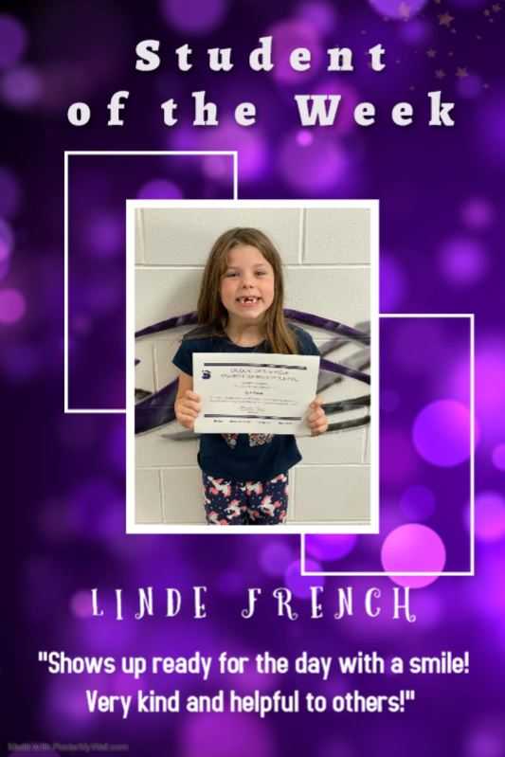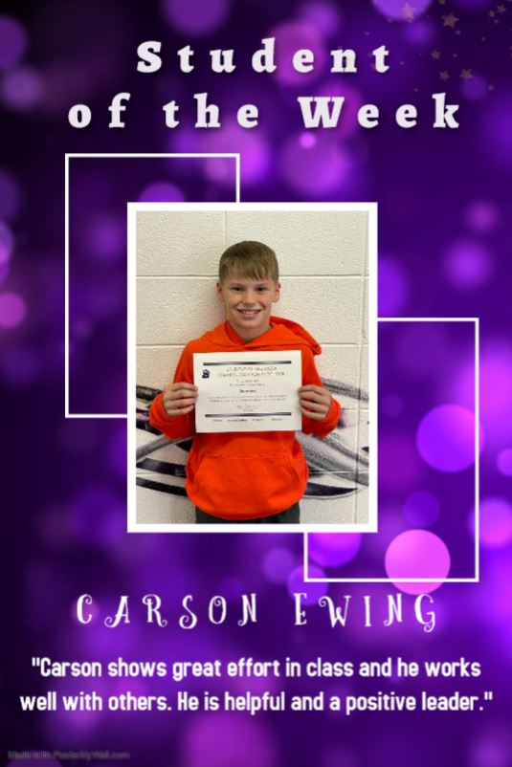

NOTICE TO PARENTS:
STUDENT LOCKERS AND DESKS – Although school lockers, desks and other spaces are temporarily assigned to individual students, they remain the property of the school district at all times. The school district has a reasonable and valid interest in ensuring the lockers, desks and other spaces are properly maintained. For this reason, lockers, desks and other spaces are subject to unannounced inspections and students have no legitimate expectations of privacy in the locker, desk or other space. Periodic inspections of all or a random selection of lockers, desks or other space may be conducted by school officials in the presence of the student or another individual. Any contraband discovered during such searches shall be confiscated by school officials and may be turned over to law enforcement officials.
The contents of a student’s locker, desk or other space (coat, backpack, purse, etc.) may be searched when a school official has reasonable and articulable suspicion that the contents contains illegal or contraband items or evidence of a violation of law or school policy or rule. Such searches should be conducted in the presence of another adult witness when feasible.

