,
STANTON COMMUNITY SCHOOL October 7, 2022

SCHOOL ACTIVITIES
SCHOLASTIC BOOK FAIR
The annual Scholastic Book Fair will be held Monday, October 24th through Thursday, October 27th during regular school hours. On Thursday, October 27th – the book fair will be open extended hours (8:00 am to 7:45 pm) during Parent Teacher Conferences. The book fair is always a wonderful opportunity to grab some holiday gifts and every book purchased benefits our school library. Thank you for your support!
Pumpkin Patch Visit
First Grade has been learning about the Life Cycles of Pumpkins. They got to take a special trip to Kelli Bucy's Pumpkin Patch!
Elementary Trash Bag Fundraiser
We have restocked our trash bag supply in the elementary office. All three sizes of trash bags are available for purchase. The rolls are $12.00 each and checks should be made payable to Stanton Schools. If you are interested in purchasing trash bags please call the elementary office at 829-2171.
It’s Socktober!
The Stanton 5th Grade is accepting donations of new, in-package socks to send to Service Members and Veterans through SoldiersAngels.org. Donations can be sent to school with a student or dropped off in the elementary office by October 26th. The fifth graders are very excited about this project so please help achieve their goal if you are able to help out!
Stanton District Strategic Planning Committee
The Stanton Community School Board is looking for two to three community volunteers to be placed on the District Strategic Planning Committee. The committee would help the school board prioritize both current and future building needs. This committee will consist of community members, school staff members, and school board members. We anticipate several evening meetings this fall/winter with possible follow-up meetings if needed. If you are interested or have any questions, please reach out to David Gute, Superintendent, at (712) 829-2162. You may also email Mr. Gute at dgute@stantonschools.com.

FROM THE DESK OF THE PRINCIPAL.
The end of the first quarter is Friday, October 21st. Parent-Teacher Conferences will be held on Thursday, October 27th from 8 am - 8 pm.
- Elementary teachers will be scheduling conference times with parents in the next few weeks.
- MS/HS parent teacher conferences will be located in classrooms from 8 am - 4 pm. All MS/HS teachers will be in a central location in the library from 4 pm - 8 pm.
Upcoming Dates:
- October 12th - Picture Retake Day
- October 21st - End of 1st Quarter
- October 27th - Parent Teacher Conferences
- October 28th - No School

ATHLETICS
Viqueen Volleyball
The Queens traveled to Jefferson, Iowa on Saturday, October 1st for the Greene County Tournament. In pool play, the Queens secured victories over 2A state-ranked South Hardin, 4A Carlisle and 1A Nodaway Valley for first place in their pool. In the Championsip bracket, the team battled in a 3-set win over 3A Greene County and secured the championship with a win over 2A Pella Christian. Great job girls!!
On Tuesday, the Viqueens hosted fellow conference team East Mills. In junior varsity play, the Queens came away with only their second loss of the season but played a very balanced match! In varsity action, the Queens put in yet another strong performance for the week and came away with a victory in four sets. On Tuesday, the team will travel to Essex for their last conference match of the season. On Saturday, October 15th, the varsity squad will travel to the Lewis Central tournament. Regional play for all 1A teams will begin on Monday, October 17th. What a season it has been for the 25-6 Queens!
Jr. High Volleyball
The junior high team hosted East Mills on Tuesday night. We split our matches with East Mills. Scores were 10-21, 21-8 17-19 and 15-10. The team will be on the court their final time this season next Tuesday when they travel to Essex. The girls have improved greatly throughout the season and continue to gain confidence! Come out and watch their last match at Essex!
Viking Football
The Vikings remain unbeaten at home this season with a victory over Murray last Friday night! The Vikings will travel this week to Bedford. Both teams need another district win to keep their playoff hopes alive! Kickoff in Bedford is at 7:00 p.m.
Junior Varsity Football
The JV team came up just short this past Monday 26-30 vs Fremont-Mills. The JV game schedule has come to a close due a lack of finding other JV 8-player teams.
Junior High Football
The JH team got on the scoreboard at Fremont-Mills, but were unable to overcome a few quick scores by the Knights. The JH team will wrap up their season next Monday as they travel to Lenox. Kickoff will be at 4:00.
Cross County
The Stanton Cross Country team ran in their 5th meet of the 2022 season in Shenandoah on Thursday, September 30. This was our second time running the Shenandoah course. For the first time this year, we had both our junior high and high school teams competing at the same meet.
In junior high, we had Brett Hart (7) run 44 seconds faster with a time of 14 minutes even. Jayden Snow (7) came in next for Stanton with a time of 14:39, over a minute faster than his last race. Lauren Roberts (7) was next with a time of 14:40, six minutes and 26 seconds faster than her last race!!!! Piper French (7) was next finishing over a minute faster, with a time of 15:50. Nick Herrick (8) shaved a minute twenty off his time of 15:55. But Grant Spencer (8) stole the show! He set a personal goal of running in less than 20 minutes. He reached that goal last week and went ahead and destroyed his last time running 3 minutes faster and finishing with a time of 16:24! Lily Ford ran over 2 minutes faster for a personal best of 17:56! Everyone on the junior high team ran their personal best!
Our JV runners also did amazing last night! Hannah Olson (10) finished in the top 20 with a time of 27:49. Riley Burke (10) ran two minutes and 14 seconds faster than her previous personal best, running a time of 29:48. Zooey Allen (10) is continuing to push himself in practice and meets and has improved so much. When looking at times from the first time we ran in Shenandoah, Zooey ran three minutes and 34 seconds faster with a time of 22:55, his best yet. Kyle Pastore (12) finished with a season-best 24:20 and Eric Kutzli (9) ran almost 3 minutes faster than his last meet with a time of 26:31. The entire JV team had their personal best!
Addison Olson (SR) was our lone varsity runner Thursday. She started off very strong! Unfortunately, Addison fell shortly after the race began and battled some soreness the entire race. Addison was very determined to finish her race strong and she did. She didn’t have a personal best, but her time of 27:38 was remarkable considering the circumstances.
You can catch the Vikings and ViQueens at Atlantic on Thursday, October 6.
ANNOUNCEMENTS
Montgomery County YMCA 3-on -3 League
Red Oak is hosting a youth 3-on-3 basketball league/clinic at our high school for boys in grades 3-6 on Tuesday nights starting on October 18. Signups are being run through the YMCA and the flyer is attached to this email. Walk-ins are also welcome! Teams will be created after you get to the gym on October 18th, so don't worry about finding a team! There is a $10 signup fee for the 3-on-3 league and the league will last 4 weeks.
Signup Link: https://montgomeryco.recliquecore.com/programs/110019/basketball-2022-2023/#division_3000028

Stanton Chamber of Commerce’s 16th Annual Trick

Or Treat on the Trail
Trick or Treat on the Trail will be held on Saturday, October 29th from 3 to 5 pm. There will be various groups and individuals passing out candy and treats to all of the little goblins! No dogs, please!
Clover Kids
Clover Kids is a fun 4-H program designed for kindergarten through third-grade children. Clover Kids
fosters positive relationships and builds valuable life skills through a variety of hands-on activities. The
Stanton Clover Kids will meet on the second Wednesday of the month immediately following the school
day, until 2:30 at the Viking Center. If you have questions or want to enroll your child, please contact the
Montgomery County Extension Office at 712.623.2592 or email xmontgomery@iastate.edu
Join 4-H!
4-H is a community of 6 million young people across the world who are learning how to live healthily, be
leaders, become engaged in their communities, and use science and technology to make good decisions
for their future and their communities. Montgomery County currently has four 4-H Clubs (for youth in
grades 4-12). We will help you find a club that works for your family. Please email
xmontgomery@iastate.edu or call 712.623.2592 so we can help you with that process.

COMING EVENTS
Friday, Oct. 7th 7:00 HS Football at Bedford
Monday, Oct. 10th 4:00 JH Football at Lenox
6:00 JV Football at Lenox
Tuesday, Oct. 11th 4:00 JH Volleyball at Essex
5:30 HS Volleyball at Essex
Wednesday, Oct. 12th Picture Re-Take Day
1:05/1:15 Early Dismissal
Thursday, Oct. 13th Cross Country at Treynor
Friday, Oct. 14th 7:00 HS Football with East Mills
Saturday, Oct. 15th Lewis Central Volleyball Tourney

BREAKFAST MENUS OCTOBER 10- OCTOBER 14TH
Monday  Cereal  Muffin/Fruit  Juice/Milk | Tuesday  Cookie  Muffin/Fruit  Juice, Milk | Wednesday  Breakfast Bagel  Muffin/Fruit  Juice, Milk | Thursday  Breakfast Bar  Muffin/Fruit  Juice, Milk | Friday  Pancake Sausage on a Stick  Muffin/Fruit  Juice, Milk
LUNCH MENUS OCTOBER 10-OCTOBER 14TH
Monday  Stuffed Crust Pizza  Lettuce  Carrots  Applesauce, Pears  Milk | Tuesday  Tuna Noodle Casserole  Peas, Green Beans  Oranges, Peaches  Roll  Milk | Wednesday  Chicken Pattie/Bun  Mixed Vegetables  Tomato Juice  Fruit Medley  Applesauce  Milk | Thursday  Meatloaf  Green Beans  Cheesy Mashed Potatoes  Peaches/Mandarin Oranges, Roll  Milk | Friday  Chikcen Fried Steak/Bun  Sweet Potatoes  Baked Beans  Mandarin Oranges  Pineapple  Milk

Congratulations Naomi and Dylan!!

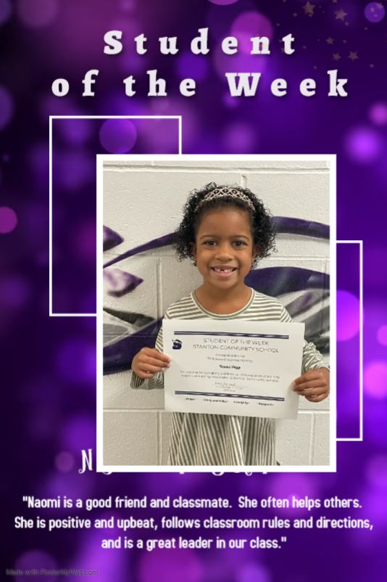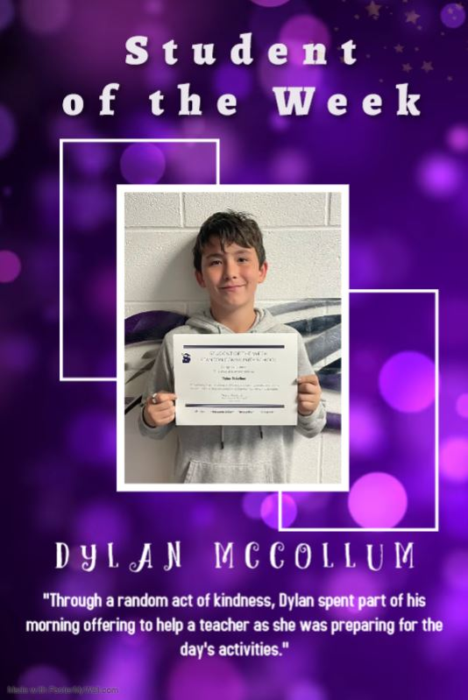
Asbestos Notification
Date: October 7, 2022
To: Parents, Students, Guardians and Employees of the Stanton Community School District
From: Board of Directors of the Stanton Community School District
David Gute, Superintendent, Asbestos Program manager
Re: Asbestos Notification
The United States Congress has enacted a piece of legislation entitled “Asbestos Hazard Emergency Response Act,” or AHERA, which requires all public and private schools in the nation to comply with the provisions by October 12, 1988. AHERA supersedes a previous federal law, “Asbestos In Schools” or AIS, which was enacted in 1982. The purpose of the legislation is to ensure that all students and employees of the nation’s schools are not subject to contact with asbestos materials, as it has been determined that inhalation of friable (flaky particles) of asbestos may lead to a cancerous disease of the lungs called asbestoses.
The Institute for Environmental Assessment was employed by the Stanton Community School District to inspect school buildings and determine if there are any asbestos containing materials (ACM), especially in the form that could represent a risk. Of most concern are areas of asbestos-bearing materials which can be easily crumbled under pressure (friable materials) and inhaled into the lungs.
Beyond the asbestos assumed to be located in some concrete, roofing felts, pipe elbows, carpet glue, etc. which is of minimal public health concern, asbestos was found in some of the following types of materials: thermal pipe joint connections; thermal pipe insulation; thermal boiler insulation; vinyl floor tile.
Stanton Community School has a minimum of ACM in its buildings. These materials have been properly encapsulated by certified EPA personnel. Signs are also posted in each of these areas. Encapsulated asbestos containing materials were found primarily in non-occupied locations such as the custodial storage room and boiler room at the High School. No known dangers to students or employees currently exist. The new elementary school is asbestos free.

A detailed Asbestos Management Building Plan is on file in the school building. This plan may be inspected by the public upon request. A District Plan is also available for review at the office of the

Superintendent of Schools. The Stanton School District has complied with recent legislation and has sent an Asbestos Management Plan to the State Department of Education prior to the deadline.
The Board of Directors and Administration plan to meet or exceed EPA standards as required by law and do whatever is necessary to continually ensure a healthy working/teaching/learning school environment. As always, your input and/or concerns are welcome. On behalf of the board of Directors, I would like to thank you for your continued support and cooperation

