STANTON COMMUNITY SCHOOL SEPTEMBER 30 2022

SCHOOL ACTIVITIES
GOLD for Childhood Cancer Awareness Month
On Friday, September 30th at the football game with Murry, please wear GOLD for Childhood Cancer!!
Childhood cancer remains the #1 cause of death by disease for children in America. Each year in the US, an estimated 15,780 children aged 0-19 are diagnosed with cancer. In 2009 and 2012 we had 2 students in school that were diagnosed with cancer.
If you know anyone that has been diagnosed with Childhood Cancer, please let Katie Elwood know by next Wednesday, September 28th we would like to honor them at halftime of the football game.
We want to bring awareness, because "KIDS CAN'T FIGHT CANCER ALONE!" Please join us tonight at 7 p.m. LET'S GO GOLD under the LIGHTS on FRIDAY NIGHT!!
Hart Named to All-Iowa Honor Dance Team
Congratulations to Kyla Hart on being selected to the All-Iowa Honor Dance Team. Kyla will perform at the State basketball tournaments in March.
Dance Camp
Reminder that the little girls dance cheer camp will perform at the halftime of the home game Friday, September 30th. Please have your child down by cheerleaders when there are 2 min left in the 2nd quarter. The High School dance team will perform after!
It’s Socktober!
The Stanton 5th Grade is accepting donations of new, in-package socks to send to Service Members and Veterans through SoldiersAngels.org. Donations can be sent to school with a student or dropped off in the elementary office by October 26th. The fifth graders are very excited about this project so please help achieve their goal if you are able to help out!
Way to go Viking Marching Band!
The Jr. High/High School Viking Marching Band earned second place in the High School division at the Shenfest street marching competition last week! We will be competing this weekend in the Clarinda Band Jamboree. Thanks for all the encouragement from teachers, fellow students and parents for the band members. We will be playing the national anthem and school song at this Friday nights football game.
Community Pep Band
Anyone interested in joining our community pep band, please come to practice with us on Tuesday evenings in the high school music room at 7pm. Students and community members are invited to join us. Dust off those instruments and join us. Contact Mr. Lantz at llantz@stantonschools.com if you would like to borrow a used instrument or if you have any questions.
5th Grade Band Meeting
5th Grade students and parents - Please come to an instrument display by Reiman Music this next Wednesday, October 5th in the High School Music Room. If you have your own instrument already, you don't need to come to this meeting. This meeting is for students and parents who wish to rent or purchase a band instrument.
Music Parents Tailgate Supper
The Music parents will be hosting a Walking Taco fundraiser meal Friday, September 30th when the football team hosts Murray for Parent’s Night. Serving will be from 5:30 to 7:00 PM in the lunchroom of the high school. Please come out and support the music parents and their students as well as the music program!
Stanton FFA
The Stanton FFA Chapter competed at the Southwest District Soils Evaluation contest on Wednesday, September 21st at Griswold High School and the Armstrong Research Farm near Lewis, Iowa. The team consisting of Caden Sallach, Clark Spencer, Dacey Henneman and Ella Peterson earned 4th place gold in the District, with Caden placing 9th overall. The team placed 3rd in the test portion of the contest and 4th in the soil pit portion of the contest. The 4th place overall finish qualifies the team to compete at the Iowa FFA State Soils Evaluation Career Development Event at Iowa State University in Ames, Iowa on Saturday, October 15th.

ATHLETICS.
Viking Football
The Vikings suffered their second loss in district play last Friday at hands of the undefeated Lenox Tigers. The Vikings dropped a touchdown pass on 4th down on their opening drive, but created a fumble and took advantage of that to open the game with a 8-0 lead. The Tigers rallied for 32 before the Vikings could put another drive together in the 2nd quarter to get the next score. The Vikings will take on the Murray Mustangs in a non-district game this Friday at home. It is also Parents' Night. Kickoff is at 7 pm.
Junior Varisty Football
The JV team put together their best performance of the season despite only being able to pad up 11 players. The Vikings defeated the Griswold Tigers to earn their first victory of the season!! The JV will play their last game of the season next Monday in Tabor vs Fremont-Mills. Kickoff is at 6 pm
JH Football
The JH team continues to improve as they moved the ball better and tackling is coming along. The JH team continues to stay upbeat and enthusiastic in practices as they prepare for Fremont-Mills. The JH will kickoff at 4 pm next Monday at Tabor.
Viqueen Volleyball
Last Saturday, the varsity Viqueens were in action at the Beford tournament. The team came out strong and were victorious in all pool play matches with wins over Mt Ayr, Lamoni and East Mills. The team was seeded first in their pool and played #2 seed, St. Albert from the other pool in the first round of the championship matches. The Queens came out on top winning 2/3 sets. In the finals, the team was once again up against Corner Conference team East Mills. The Viqueens lost the first set (20-25), won the second set (25-17) and lost the very exciting third set (21-19 to place second for the day in a very competitive tournament. Congratulations team!
On Monday, we hosted three other teams from the conference for the opening night of the Corner Conference tournament week. The Queens won their match against Hamburg (25-9, 25-4 and 25-11). On Tuesday night, the team traveled to Sideny to meet up with East Mills for the third time in four days. The Queens struggled to find any consistency in their level of play and dropped the match in three sets. On Thursday, the team traveled to Tabor for the Consolation bracket of the tournament with a match against Fremont-Mills.
On Saturday, the varsity squad will travel to Jefferson, Iowa for the Greene County Tournament. The Queens pool play schedule is:
9:00 am Stanton v South Hardin
11:30 Sttanton v Carlisle
1:00 Stanton v Nodaway Valley
*times are approximate and championship rounds follow pool play.
On Tuesday, October 4th, the Viqueens will host East Mills and also observe Parents Night for all of our players and parents. Junior varsity action begins at 5:30.
Junior High Volleyball
The junior high squad will host East Mills on Tuesday, October 4th. The following week they will travel to Tabor on Monday, October 10th for a Junior High Jamboree and then travel to Essex the following day for a match with Essex. All matches begin at 4:00.
From the Desk of the Principal
Sunday, October 2nd is National School Custodian Day. We want to thank Sandy Allen and Bob Reed for all they do to keep our school clean and safe!

Please note that Parent-Teacher Conferences will be held on Thursday, October 27th from 8 am - 8 pm.
- Elementary teachers will be scheduling conference times with parents in the next few weeks.
- MS/HS parent teacher conferences will be located in classrooms from 8 am - 4 pm. All MS/HS teachers will be in a central location in the library from 4 pm - 8 pm.
- Due to conferences, we will not have school on Thursday, October 27th or Friday, October 28th.
Upcoming Dates:
- October 12th - Picture Retake Day
- October 21st - End of 1st Quarter
- October 27th - Parent Teacher Conferences
- October 28th - No School

ANNOUNCEMENTS
5th Quarter
Our first 5th Quarter will be Friday, September 30th at Mamrelund Lutheran Church. 5th Quarter is open to any Stanton student from 7th -12th grade. It is a safe place to hang out after Friday night home games. It takes approximately $200 for each 5th Quarter to happen. We usually feed between 60-70 junior high and high school students. In order for this to continue, we need money and/or people willing to donate food. We have an account at First Interstate Bank (formerly Great Western Bank). You can go to the bank and make a deposit directly to 5th Quarter or contact Leanne Johnson at the school. Thank you for all of your help to make this happen for our kids.

Stanton Chamber of Commerce’s 16th Annual Trick or Treat on the Trail
Trick or Treat on the Trail will be held on Saturday, October 29th from 3 to 5 pm. There will be various groups and individuals passing out candy and treats to all of the little goblins! No dogs, please!

COMING EVENTS
Friday, 30th 7:00 PM HS FB with Murray (Parents Night)
Saturday, Oct 1st 9:00 Varsity VB at Greene County Tournament
Clarinda Band Jamboree
Monday, Oct 3rd 4: 00 Junior High FB @ Fremont-Mills
6:00 Junior Varsity FB @ Fremont-Mills
Tuesday, Oct. 4th 4:00 Junior High VB with East Mills
5:30 High School VB with East Mills
(Parents Night)
Wednesday, Oct 5th Early Dismissal 1:05/1:15
Thursday, Oct. 6th 7:30 AM FFA meeting
XC at Atlantic
Friday, Oct. 7th 7:00 HS Football at Bedford
Saturday, Oct 8th 9:00 AM Red Oak Freshmen VB Tourney

BREAKFAST MENUS OCTOBER 3 – OCTBOER 7
Monday  Cereal Bar  Muffin  Juice, Milk | Tuesday  Oatmeal Bar  Muffin/Fruit  Juice, Milk | Wednesday  Waffle  Muffin/Fruit  Juice, Milk | Thursday  Donut  Muffin/Fruit  Juice, Milk | Friday  Cinni Mini  Muffin/Fruit  Juice, Milk
LUNCH MENUS OCTOBER 3—OCTOBER 7
Monday  Crispito/Hot Dog  Corn  Celery  Mandarin Oranges, Raisins  Milk | Tuesday  Chicken Nuggets  Coleslaw  Baked Beans  Oranges, Pineapple  Banana Muffin  Milk | Wednesday  Ham & Cheese Sandwich  Peas, Green Beans  Peaches, Mixed Fruit  Strawberries, Rice  Milk | Thursday  Italian Pasta  Lettuce  Carrots  Pears/Applesauce  Breadstick  Milk | Friday  Chicken Wrap  Lettuce, Cheese  Mixed Veggies  Cooked Carrots  Mandarin Oranges  Milk

Students of the Week for Week of September 19th
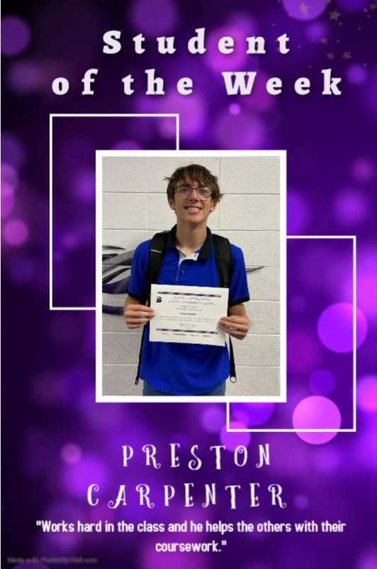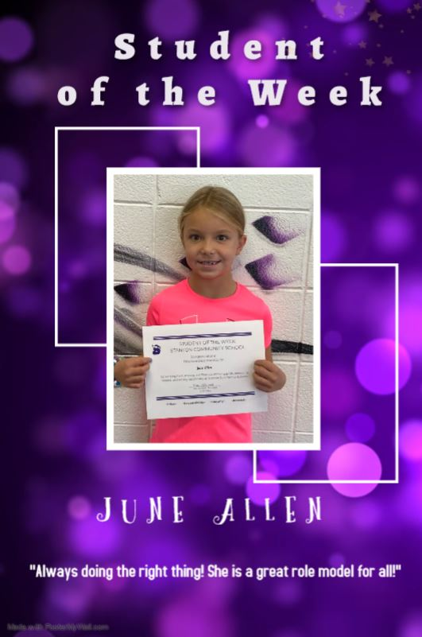

Students of the Week for the Week of September 26

