STANTON COMMUNITY SCHOOL FEBRUARY 12, 2021

SUPERINTENDENT
There is a bill in the Iowa Senate (SF159) that is proposing taxpayer funds be allowed to follow students to private schools, charter schools, and homeschooling. This will ultimately divert funds from public education. It is estimated to cost between 3 and 54 million dollars. Please research this proposal and reach out to a locally elected legislature and to let them know your opinion on this bill.
1. Rules and Transparency must follow public money. We taxpayers have the right to expect those who choose to accept public money follow the same rules and transparency required of public schools.
2. Iowa performs better than any state with ESA/Vouchers. Governor Reynolds cited USNews data with Iowa ranked 13th in the nation in PRE K-12 education. The state with ESA/Vouchers rank well below us. Why would we look for solutions below us?
3. Vouchers pull valuable resources out of rural schools. 240 of the 327 Iowa school districts don’t have a private school in their district to even use a voucher. Rural schools can’t afford to have tax dollars pulled away from their community schools to fund choice in other areas.
Cecil Dolecheck
cecil.dolecheck@legis.iowa.gov
515.281.3221

Mark Costello
mark.costello@legis.iowa.gov
515.281.3371

David Sieck
David.Sieck@legis.iowa.gov
515.281.3221

PRINCIPAL
Parent Teacher Conferences are scheduled for Thursday, February 25th, from 8:00 AM-8:00 PM. Information was sent via email this week regarding virtual or phone conferences. Please check your email for instructions on signing up for a conference time with your child’s teachers. Please contact the office if you have further questions. The elementary office phone number is 712-829-2171 and the secondary office is 712-829-2162. We look forward to meeting with you to discuss your child’s progress in school!
As many of you know, the governor’s most recent proclamation included an update on masks. However, it also stated that we as a district are responsible for continuing to ensure the safety of our students and staff during COVID-19. In our communication with Montgomery County Public Health the quarantine guidance has not changed for those students and staff who are wearing masks. Therefore, please note that face masks are still required in school, at school activities, and on school buses. Any mitigation strategies that were already in place for athletic events and activities will continue to be in place. Each participant and coach will continue to get six tickets per participant for games. We want to continue to keep everyone safe, and in school as much as possible. Thank you for your assistance, and all you have done this year to help ensure the safety of our students and staff!

SCHOOL ACTIVITIES.
Yearbook
The 2021 “BLEEDING PURPLE AND WHITE” yearbook is for sale. This yearbook would make a great Valentine’s Day gift. Cost of the book is $60.00. Contact a yearbook staffer to order and pay for your book.

You may also purchase your yearbook online with a credit card. To order online, go to
www.stantonschools.com and click on the picture that you see pictured. That will take you

to shopjostens.com where you can purchase your book.
You can personalize your yearbook as follows:
Icons (up to 4) for $3.65
One line of personalization for $6.25
Regardless of which method you use to order, the book will have lots of colorful moments that the staff is working very hard on so you will not want to miss out on a great “BLEEDING PURPLE AND WHITE” book about Stanton High School.
FCCLA/Red Cross Blood Drive-March 17th
Please call the school office at 829-2162 or visit RedCrossBlood.org and enter: Vikings to schedule an appointment. STUDENTS - Please stop in the office to make an appointment. By donating blood at the Stanton High School drive, not only are you helping save lives, you are also helping the school earn a scholarship for one or more of their graduating seniors.

ATHLETICS
Viking Basketball
The Vikings finished off the regular season Tuesday night with a win over Clarinda Academy. Earlier in the week, the Vikes lost a heartbreaker against the Conference Champions, East Mills, by a score of 57-60. As the regular season wrapped up the Vikes finished with a record of 12-7. After returning 1 starter and the 4th fewest points in 1A from last season's District Semifinal team, Coach Lord was impressed with this group's fight. They were in every game they played all season long and came away with 12 hard fought wins and 7 really close losses. The Vikes look forward to competing in the District tournament and open up with a game at #3 seed Riverside on Monday night. If you're able to make it up to Oakland, wear purple and cheer loud as the Vikes look to upset the Bulldogs and make a run through the District Tournament. Go Vikes!
Viqueen Basketball
Viqueen's take Corner Conference Regular Season Crown
A 49-27 victory over East Mills Monday evening put an explanation point on the regular season conference championship for the Queen's. A quick start by the Queen's came in handy as a scoring drought in the second quarter allowed a 16-6 advantage dip to 16-12 at half. Coach Dave Snyder said, "We could not buy a basket in the 2nd quarter, East Mills was controlling the pace of the game and that may have had something to do with it. It is somewhat amazing that we maintained a lead a half without scoring a point in the 2nd quarter, obviously our defensive play kept us in the game.” Offensively the Queen's would rebound in the second half scoring 33 points while a very stingy defense maintained the entire game.
Winning the regular season championship was another season goal for the Queen's as they looked forward to Regionals last night at home vs Bedford.
Jr. High Boys Basketball Reminder
A reminder to all JH boys' basketball players. Please turn in your game jersey and shorts, as well as your practice tops.
Junior High Girls Track
The junior high girls track team will begin practice on Monday, March 1st. The week of March 1st and the week of March 8th, the team will conclude practice at school dismissal time daily (3:18 p.m.). Beginning Monday, March 15th, the team will practice 8th hour and after school until 4:15 daily. The first track meet for the team is scheduled for Tuesday, April 13th, as we host our Jr. Viking and Viqueen Relays at home. An updated meet schedule will be sent home with the girls the first week of practice.

COMING EVENTS
Monday, 15th 7:00-Boys District Basketball at Riverside
Stanton vs Riverside
Tuesday, 16th 7:00-Girls Regional Basketball, Here
Wednesday, 17th 1:05/1:15-Early Dismissal
Thursday, 18th 7:00-Boys District Basketball at CAM
Friday, 19th 7:00-Girls Regional Basketball at Exira-EHK

BREAKFAST MENUS FEBRUARY 15-19
Monday  Breakfast Brownie  Muffin/Fruit  Juice/Milk | Tuesday  Biscuit With Gravy  Muffin/Fruit  Juice/Milk | Wednesday  Crescent Roll  Muffin/Fruit  Juice/Milk | Thursday  Breakfast Pizza  Muffin/Fruit  Juice/Milk | Friday  Pancakes  Muffin/Fruit  Juice/Milk
LUNCH MENUS FEBRUARY 15-19
Monday  Hamburger/Bun  Tri-Tater  Baked Beans  Mixed Fruit  Cherry Crisp  Milk | Tuesday  Beef Fritter  Mashed Potatoes/Gravy  Cooked Carrots  Pineapple  Apricots  Milk | Wednesday  Fish Sandwich  Cheesy Hashrounds  Baked Beans  Mandarin Oranges  Applesauce  Milk | Thursday  Grilled Chicken  Mixed Vegetables  Garbanzo Beans  Oranges/Peaches  Chocolate Cake  Milk | Friday  Cheese Ravioli  Lettuce/Corn  Pears  Applesauce  Breadstick  Milk

STANTON COMMUNITY SCHOOL
PATRON NOTIFICATION OF
OPEN ENROLLMENT REQUIREMENTS
Parents/guardians considering the use of the open enrollment option to enroll their child/ren in another public school district in the state of Iowa should be aware of the following dates:
March 1, 2021—Last date for regular open enrollment requests for the 2021-2022 school year for students in grades 1-12.
September 1, 2021—Last date for open enrollment requests for entering kindergarten students and those students falling under the “good cause” definition for the 2021-2022 school year.
Parents/guardians of open enrolled students whose income falls below 160% of the federal poverty guidelines are eligible for transportation assistance. This may be in the form of actual transportation or in the form of a cash stipend.
Parents should be aware that open enrollment may result in the loss of athletic eligibility.
For further details, contact the school office at 712-829-2162

Girls Regionals
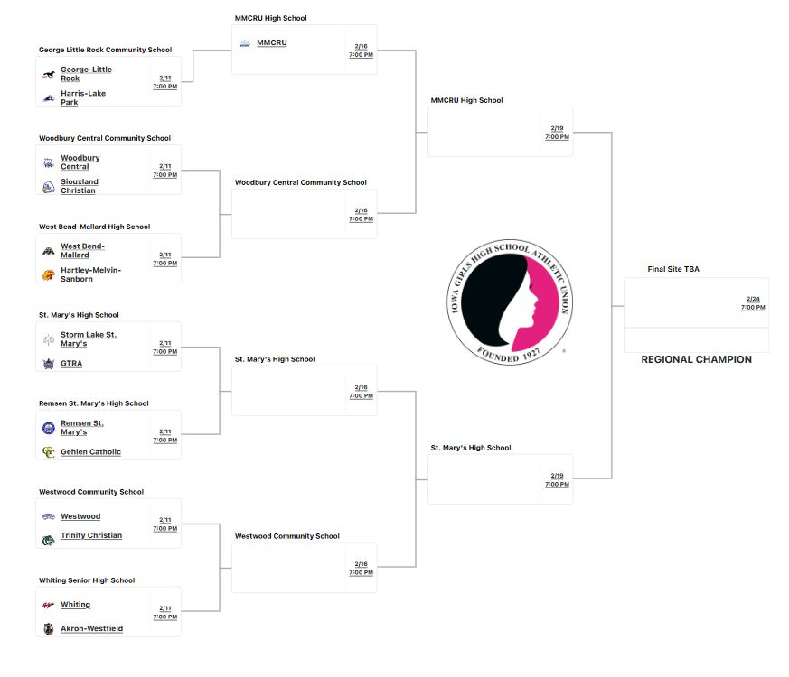

Boys Districts
